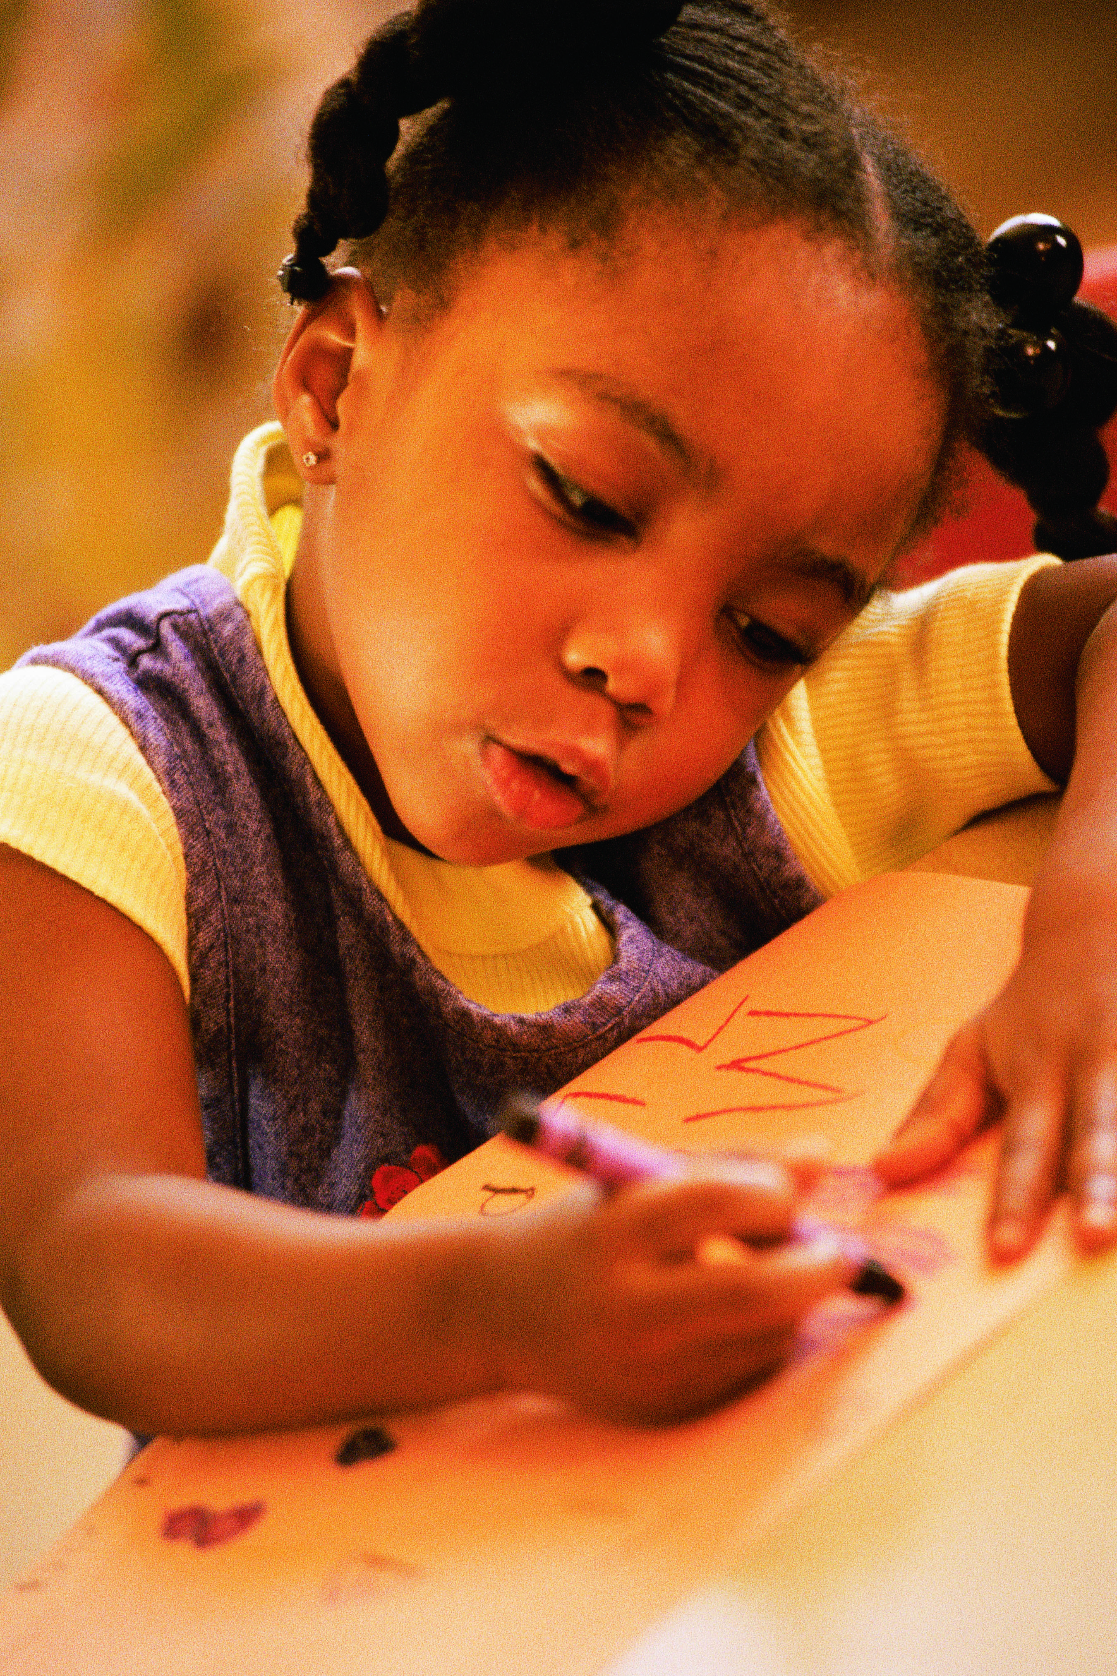

ELA

Common Core

State Standards

Resource Materials Packet

**Kindergarten**

**Oral Language: Building a Talking Community**

**Unit 1**

**08/26/13**

**Table of Contents**

Mentor Text List. 3

How to Write a Story. 4

Ways to Practice My Story 5

Parent letter 6

Class Profile of Teaching and Learning Points 7

Some Possibilities for Purposeful Use of the Share Time 8

Oral Language Checklist 9

**Mentor Texts – Kindergarten, Unit #1 Oral Language**

* **These are only suggested lists. Teachers may find other texts that fit the criteria. Please review books you have available that also meet the criteria and add to the list.**
* **These are some titles that fit the following criteria: 1)** **characters are human, 2) topics are about everyday ordinary things**

|  |  |  |
| --- | --- | --- |
| **Literature – Trade Book Suggestions** | | |
| **Title** | **Author** | **Notes to Teacher** |
| *Too Many Toys | David Shannon |  |
|  |  |  |
|  |  |  |

* = mentor text used in sessions

|  |  |  |
| --- | --- | --- |
| **Student Authored Work Code: SW** | | |
| **Author** | **Topic/Title** | **Notes to Teacher** |
|  |  |  |
|  |  |  |

|  |  |  |
| --- | --- | --- |
| **Teacher Authored Work Code: TW** | | |
| **Author** | **Topic/Title** | **Notes to Teacher** |
|  |  |  |
|  |  |  |

|  |  |  |
| --- | --- | --- |
| **Common Core Code: CC** | | |
| **Author** | **Topic/Title** | **Notes to Teacher** |
|  |  |  |
|  |  |  |

|  |  |  |
| --- | --- | --- |
| **Teachers College (**www.readingandwritingproject.com) **Code: TC** | | |
| **Author** | **Topic/Title** | **Notes to Teacher** |
|  |  |  |

|  |
| --- |
| **Websites Code: WWW** |
|  |

**How to Write a Story?**



Think

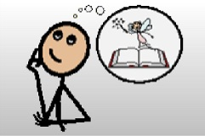

Picture



Say

Sketch 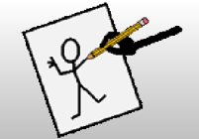

Write 

**Ways to Practice My Story**

|  |  |
| --- | --- |
| **Ways to Practice My Story**  **\*Self**    **\*Partner**  C:\Users\Jen\Desktop\image001.jpg    **\*Story Hand**  **Blank Handprint**  **\*Story Across Pages**  **--Touch pages**  **j0123493**  j0123493j0123493 **Sketch**    Biondo, May 2011 | **Ways to Practice My Story**  **\*Self**    **\*Partner**  C:\Users\Jen\Desktop\image001.jpg    **\*Story Hand**  **Blank Handprint**  **\*Story Across Pages**  **--Touch pages**  **j0123493**  j0123493j0123493 **Sketch**    Biondo, May 2011 |

Dear Families,

We have begun our first unit of study in writing. The unit is titled “Oral Language: Building a Talking Community.” We begin the school year with oral language, or talking, because it is something that all children can do when they come to school. By inviting children to tell stories about themselves and things they know and can do we honor them for who they are, and as a class we will get to know each other.

In this unit, your child will learn to:

* Talk about things he/she knows and can do (everyday, ordinary events)
* Use a voice loud enough for the listener to hear, and look at his/her audience when speaking
* Listen when others tell stories
* Think, picture, and say his/her story to him/herself and a partner

To support your child’s oral storytelling you can:

* Tell stories about things you know and can do (everyday, ordinary events to which your child can relate)
* Ask your child to tell you the story he/she told at school
* Help your child remember stories
* Practice telling stories at home, and encourage him/her to tell these stories at school too

As your child is telling stories, say things like:

* What is your story about?
* Can you picture your story?
* How will your story go?
* What happens next?
* Repeat your child’s story and ask if you got it right
* Have your child repeat his/her story several times
* Have your child tell his/her across his/her hand (On Saturday I went to the store- one finger, my mom and I got milk-next finger, etc.)

Have fun telling and listening to stories about things you and your child know and can do!

Thank you for your support.

Sincerely,

|  |  |  |  |  |  |  |  |  |  |  |  |  |  |  |  |  |  |
| --- | --- | --- | --- | --- | --- | --- | --- | --- | --- | --- | --- | --- | --- | --- | --- | --- | --- |
| Student Names | Writers tell a story about things they know and do. | Writers use a voice people can hear and look at the audience when they tell stories about things they know and do. | Writers actively listen when others tell stories. | Writers take turns being a speaker and a listener. | Writers take turns being a speaker and a listener (repeat of lesson 4). | Writers listen and respond to the speaker. | Writers use sources to generate story ideas. | Writers choose and think about a meaningful experience and share. | Writers plan their story by thinking about their story idea and orally rehearsing to self | Writers think, picture, and say their stories to themselves and partner. |  |  |  |  |  |  |  |
|  |  |  |  |  |  |  |  |  |  |  |  |  |  |  |  |  |  |
|  |  |  |  |  |  |  |  |  |  |  |  |  |  |  |  |  |  |
|  |  |  |  |  |  |  |  |  |  |  |  |  |  |  |  |  |  |
|  |  |  |  |  |  |  |  |  |  |  |  |  |  |  |  |  |  |
|  |  |  |  |  |  |  |  |  |  |  |  |  |  |  |  |  |  |
|  |  |  |  |  |  |  |  |  |  |  |  |  |  |  |  |  |  |
|  |  |  |  |  |  |  |  |  |  |  |  |  |  |  |  |  |  |
|  |  |  |  |  |  |  |  |  |  |  |  |  |  |  |  |  |  |
|  |  |  |  |  |  |  |  |  |  |  |  |  |  |  |  |  |  |
|  |  |  |  |  |  |  |  |  |  |  |  |  |  |  |  |  |  |
|  |  |  |  |  |  |  |  |  |  |  |  |  |  |  |  |  |  |
|  |  |  |  |  |  |  |  |  |  |  |  |  |  |  |  |  |  |
|  |  |  |  |  |  |  |  |  |  |  |  |  |  |  |  |  |  |
|  |  |  |  |  |  |  |  |  |  |  |  |  |  |  |  |  |  |
|  |  |  |  |  |  |  |  |  |  |  |  |  |  |  |  |  |  |
|  |  |  |  |  |  |  |  |  |  |  |  |  |  |  |  |  |  |
|  |  |  |  |  |  |  |  |  |  |  |  |  |  |  |  |  |  |
|  |  |  |  |  |  |  |  |  |  |  |  |  |  |  |  |  |  |
|  |  |  |  |  |  |  |  |  |  |  |  |  |  |  |  |  |  |
|  |  |  |  |  |  |  |  |  |  |  |  |  |  |  |  |  |  |
|  |  |  |  |  |  |  |  |  |  |  |  |  |  |  |  |  |  |
|  |  |  |  |  |  |  |  |  |  |  |  |  |  |  |  |  |  |
|  |  |  |  |  |  |  |  |  |  |  |  |  |  |  |  |  |  |

**Class Profile of Teaching and Learning Points – Kindergarten Unit 1: Oral Language Optional Assessment/Conferring Tool**

**Each lesson has a share component. Modify based on students’ needs. The following are other share options.**

**Some Possibilities for Purposeful Use of the Share Time**

|  |  |  |
| --- | --- | --- |
| Name | Purpose | Method |
| Follow-Up on  Mini-Lesson | To reinforce and/or  clarify the teaching point | * Share an exemplar model (student or teacher) * Share a student who had difficulty and the way in which he/she solved the problem * Share the story of a conference from the independent work time * Provide another opportunity for active engagement * Provide a prompt to initiate student conversation, “Turn and tell your partner…” |
| Problem  Solving | To build community and  solve a problem |  |
| Review | * To recall previous strategies /prior learning * To build repertoire of strategies * To contextualize learning | Pose a “review” question to the class:  “Today we learned one revision  strategy. What other revision  strategies do you use?” These  strategies may be listed on a chart. |
| Looking Ahead  to Tomorrow | Introduce a new  teaching point – set-up  for the next mini-lesson |  |
| Celebratory | * Celebration of learning * Boost student morale * Promote membership in the “literacy club” | * Share the work of 2-3 students * Provide an opportunity for a whole class share: “You are all such amazing writers - you wrote so much today! Writers, hold up your open notebooks so that we can see all of the great work you have done.” |

Source: Teachers College Reading and Writing Project

|  |  |  |  |  |  |  |  |
| --- | --- | --- | --- | --- | --- | --- | --- |
| Unit 1:  Oral Language | Talks about things they know and can do they know | Uses storyteller voice and looks at audience when telling stories | Listens when others tell stories | Takes turns being a speaker and a listener | Listens and responds to a speaker | Chooses a meaningful experience to share | Plans story: thinks, pictures and says story to self and partner |
|  |  |  |  |  |  |  |  |
|  |  |  |  |  |  |  |  |
|  |  |  |  |  |  |  |  |
|  |  |  |  |  |  |  |  |
|  |  |  |  |  |  |  |  |
|  |  |  |  |  |  |  |  |
|  |  |  |  |  |  |  |  |
|  |  |  |  |  |  |  |  |
|  |  |  |  |  |  |  |  |
|  |  |  |  |  |  |  |  |
|  |  |  |  |  |  |  |  |
|  |  |  |  |  |  |  |  |
|  |  |  |  |  |  |  |  |
|  |  |  |  |  |  |  |  |
|  |  |  |  |  |  |  |  |
|  |  |  |  |  |  |  |  |
|  |  |  |  |  |  |  |  |
|  |  |  |  |  |  |  |  |
|  |  |  |  |  |  |  |  |
|  |  |  |  |  |  |  |  |
|  |  |  |  |  |  |  |  |
|  |  |  |  |  |  |  |  |
|  |  |  |  |  |  |  |  |
|  |  |  |  |  |  |  |  |
|  |  |  |  |  |  |  |  |
|  |  |  |  |  |  |  |  |
|  |  |  |  |  |  |  |  |
|  |  |  |  |  |  |  |  |

**Oral Language Checklist**