

ELA

Common Core

State Standards

Resource Packet

**Kindergarten**

**Label and List in a Content Area**

**Unit 3**

**8/2/2013**

**Writing Unit of Study**

**Kindergarten- Label and List in a Content Area, Unit 3**

**Resource Materials Packet**

**Table of Contents**

Mentor Text 1

Label and List Mentor Text Teacher Resource 2

Editing Checklist 3

How Scientists Observe and Learn 4

Basic Parts of a Book 5

How Writers Say and Write Words 6

Paper Samples 7

Class Profile of Teaching and Learning Points 13

Proficiency Checklist 14

Some Possibilities for Purposeful Use of the Share Time 15

**Mentor Texts – Kindergarten, Unit #3 Label and List in a Content Area**

* These are only a suggested list. You may find other texts that fit the criteria. Please review books you have available that also meet the criteria and add to the list.
* There are many different types of Label and List books that are recommended for this unit. **Please see page 2 in this Resource Material packet for the teacher resource chart.** This resource will help teachers locate books within their own libraries to support immersion for this unit.
* These are some titles that fit the following criteria: 1) real information 2) meant to teach others 3) realistic pictures 4) pictures and words match 5) some books compare/contrast 6) use descriptive words to teach others.

|  |  |  |
| --- | --- | --- |
| **Literature – Trade Book Suggestions** | | |
| **Title** | **Author** | **Notes to Teacher** |
| The Listening Walk | Paul Showers | Use for How Scientist Observe and Learn |
| Scientists Ask Questions | Ginger Garrett (Rookie Read-About Science) | Use for How Scientist Observe and Learn |
| Dinosaur Days | Pam Holden (Red Rocket Readers) | Compare/Contrast |
| Leaves | Charlotte Guillain (Acorn Books-Heinemann Raintree) | Content, labels, question/answer |
| Who Lives in a Tree? | Lisa Trumbauer (Newbridge Discovery Links) | Question/Answer |
| Autumn Leaves | Ken Robbins (Scholastic) | Content |
| Oak Trees | Marcia Freeman (Capstone Press) | Content |
| Trees | Maryellen Gregoire(Capstone Press) | Different facts per page |
| Trees | Miriam Frost (the Wright Group- TWiG books) | Teaching pattern |
| Leaf Jumpers | Carole Gerber | Compare/Contrast, content |
| The Leaves on the Trees | Thom Wiley (Scholastic) | Content |
| Tell Me, Tree | Gail Gibbons | Content, Labels, Close-up pictures |

**Kindergarten Unit 3: Label and List in a Content Area**

**Mentor Text Teacher Resource**

|  |  |  |  |  |
| --- | --- | --- | --- | --- |
| **General Category­­** | | **Description/Sample of Text** | **Session(s)** | **Possible Books** |
| 1 | A. Labeling – diagram type | Leaf, green, point | 1, 2, 3, 4 |  |
| B. Labeling – words on bottom |  |  |
| 2 | Phrase (2 words) – description/object | Small leaf. Big leaf. Tiny leaf. | 5 |  |
| 3 | Book about 1 attribute | Sizes of leaves, colors of leaves,  shapes | 6 |  |
| 4 | Simple book with different facts per page |  | 7 |  |
| 5 | Pattern or list book – sentences |  | 9 |  |
| A. Naming pattern |  |  |
| 1. Pattern tells about 1 attribute of an object. | I see a (color) leaf.  Here is a (attribute) car. |  |
| **OR** answers one question about object | A squirrel lives in a tree. |  |
| 2. Pattern that lists objects. | Look at the (person, place, thing).  This is a ____________________. |  |
| B. Teaching pattern |  |  |
| 1. Pattern that teaches about one aspect of item under study. | Tree gives us ________________. |  |
| 6 | Question/possible answer page/book | What are plants? | 11 |  |
| 7 | Alike/different page/book | An acorn is brown like a football. | 14 |  |
| 8 | Content or teaching books about the area under study – information in nature, not books students will imitate. |  |  |  |

**Kindergarten: Unit 3 Label and List in a Content Area Unit Editing Checklist**

Name: _________________________________________

|  |  |  |
| --- | --- | --- |
| I checked for… |  |  |
|  | Capital “I” | **http://0.tqn.com/d/webclipart/1/0/q/L/blnksym2.gif** i I |
|  | Word wall words |  |
|  | Spaces between words |  |
|  | Scientific words |  |

How Scientists Observe and Learn



Look

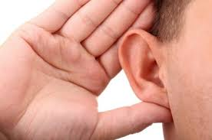

Listen

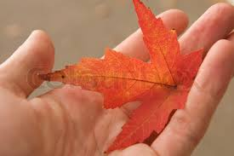

Touch

Look Again

Ask Questions

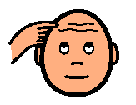 What is the reason for? . . .

Why does? . . .

Say things like . . .

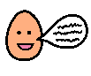 I wonder . . .I noticed . . . I’m thinking . . .

Basic Parts of a Book

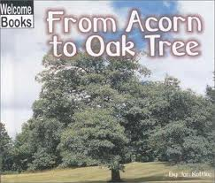

* Cover
* Title

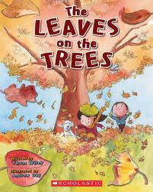

* Author/Illustrator

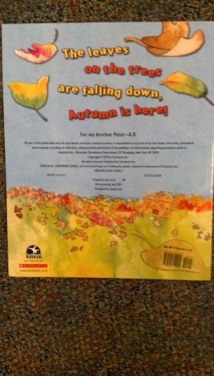

* Back Cover

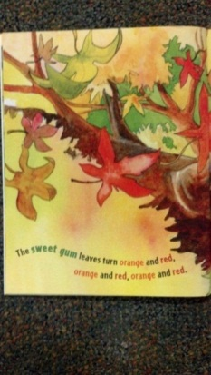

* Colored Pages

|  |
| --- |
| **How Writers Say and Write Words** |
| 1. Say the word 2. Say it again slowly 3. Write down what you hear 4. Reread and say more |



C:\Users\BarnesT\AppData\Local\Microsoft\Windows\Temporary Internet Files\Content.IE5\GEAEK3BY\MC900031061[1].wmf**Name _______________________________________ Date ________________________________________**

C:\Users\BarnesT\AppData\Local\Microsoft\Windows\Temporary Internet Files\Content.IE5\GEAEK3BY\MC900031061[1].wmf**Name _______________________________________ Date ________________________________________**

**Optional Assessment/Conferring Tool *– Kindergarten Unit 3:* Label and List Class Profile of Teaching and Learning Points**

|  |  |  |  |  |  |  |  |  |  |  |  |  |  |  |  |  |  |
| --- | --- | --- | --- | --- | --- | --- | --- | --- | --- | --- | --- | --- | --- | --- | --- | --- | --- |
| Student Names | Writers are like scientists writing down many observations. | Writers capture what they see exactly the way they find it. | Writers plan their writing across pages. | Writers decide on titles for their books (Main idea). | Writers stretch their words by writing down all the sounds they hear. | Writers/scientists sort their objects to help them organize their writing. | Writers/scientists use books to learn more about the topic. | Writers make plans to teach all about their topic. | Writers use patterns to write information about a topic. | Writers/scientists use scientific words to teach others. | Writers/scientists ask questions. | Writers need to look closely at their objects to add to the pictures and words. | Writers/scientists look closely to notice what is the same and different about objects. | Writers compare what they are writing about to something they already know. | Writers are in charge of their own writing. | Writers reread and make their writing readable for an audience. | Writers improve their writing to go public |
|  |  |  |  |  |  |  |  |  |  |  |  |  |  |  |  |  |  |
|  |  |  |  |  |  |  |  |  |  |  |  |  |  |  |  |  |  |
|  |  |  |  |  |  |  |  |  |  |  |  |  |  |  |  |  |  |
|  |  |  |  |  |  |  |  |  |  |  |  |  |  |  |  |  |  |
|  |  |  |  |  |  |  |  |  |  |  |  |  |  |  |  |  |  |
|  |  |  |  |  |  |  |  |  |  |  |  |  |  |  |  |  |  |
|  |  |  |  |  |  |  |  |  |  |  |  |  |  |  |  |  |  |
|  |  |  |  |  |  |  |  |  |  |  |  |  |  |  |  |  |  |
|  |  |  |  |  |  |  |  |  |  |  |  |  |  |  |  |  |  |
|  |  |  |  |  |  |  |  |  |  |  |  |  |  |  |  |  |  |
|  |  |  |  |  |  |  |  |  |  |  |  |  |  |  |  |  |  |
|  |  |  |  |  |  |  |  |  |  |  |  |  |  |  |  |  |  |
|  |  |  |  |  |  |  |  |  |  |  |  |  |  |  |  |  |  |
|  |  |  |  |  |  |  |  |  |  |  |  |  |  |  |  |  |  |
|  |  |  |  |  |  |  |  |  |  |  |  |  |  |  |  |  |  |
|  |  |  |  |  |  |  |  |  |  |  |  |  |  |  |  |  |  |
|  |  |  |  |  |  |  |  |  |  |  |  |  |  |  |  |  |  |
|  |  |  |  |  |  |  |  |  |  |  |  |  |  |  |  |  |  |
|  |  |  |  |  |  |  |  |  |  |  |  |  |  |  |  |  |  |
|  |  |  |  |  |  |  |  |  |  |  |  |  |  |  |  |  |  |
|  |  |  |  |  |  |  |  |  |  |  |  |  |  |  |  |  |  |
|  |  |  |  |  |  |  |  |  |  |  |  |  |  |  |  |  |  |

**Kindergarten–Label and List in a Content Area Unit Proficiency Checklist\***

**Name: ____________________________________________Date: _____________________________**

Proficiency checklists guide teachers on what to provide instruction and additional assistance on during the unit,

as well as beyond the unit. See Proficiency Guidelines in the K-2 Writing Assessment Package for additional

information.

|  |  |
| --- | --- |
| **What are this writer’s strengths?** | **What are the next teaching points for this**  **writer?** |

The following should be observed and/or evident in written work by the end of this unit:

* (T) Observes, sketches and exactly labels observations (Session 1, 2)
* (P) Sketches and writes observations across several pages (Session 3)
* **(T) Includes a title that tells the reader what they will learn about in the book (Session 4)**
* **(L) Hear and record most sounds (Session 5)**
* (T) Sorts objects into groups/categories (Session 6)
* **(P) Uses secondary sources to look for new information (Session 7)**
* (T) Tells about topic across fingers (Session 8)
* (T) Uses patterns to write information about a topic (Sessions 9)
* **(T) Uses appropriate scientific/domain specific words (Session 10)**
* (P) Asks questions about topic (why, what)to add more information to piece (Session 11)
* **(P) Revises by looking at objects again and again and adding to pictures and words (Session 12)**
* (R) Compares and contrasts objects by looking at them closely and thinking about what they already know (Session 13, 14)
* **(P) Revises by looking over their work and deciding what is good and/or what is not (Session 15)**
* **(P) Rereads and makes writing readable (Session 16)**
* (P) Improves writing by adding cover, title, author/illustrator, colored pictures, and back cover inorder to go public (Session 17)
* **(P) Demonstrates writing stamina through writing 4 to 5, 3-5 page booklets each week**
* (P) Demonstrates knowledge of workshop routines (Emphasis on rereading and partnership work) (All Sessions)

See page 26 of the ELA CCSS document for all Kindergarten Language Standards.

**\*This checklist does not have levels of proficiency because the skills taught in this unit are foundational for all**

**types of writing and writers. In addition, this unit focuses on routines, building independence, and the process**

**of writing.**

**T**-Text Types and Purposes **R**-Research to Build and Present Knowledge **P**-Production and Distribution of

Writing **L**-Language

Created by Melissa Wing, Genesee Intermediate School District, Kathy Smith, Bendle Public Schools, Pam Bachner and Aimee Torok, Grand Blanc Schools. (Updated July 2013)

**Each lesson has a share component. Modify based on students’ needs. The following are other share options.**

**Some Possibilities for Purposeful Use of the Share Time**

|  |  |  |
| --- | --- | --- |
| Name | Purpose | Method |
| Follow-Up on  Mini-Lesson | To reinforce and/or  clarify the teaching point | * Share an exemplar model (student or teacher) * Share a student who had difficulty and the way in which he/she solved the problem * Share the story of a conference from the independent work time * Provide another opportunity for active engagement * Provide a prompt to initiate student conversation, “Turn and tell your partner…” |
| Problem  Solving | To build community and  solve a problem |  |
| Review | * To recall previous strategies /prior learning * To build repertoire of strategies * To contextualize learning | Pose a “review” question to the class:  “Today we learned one revision  strategy. What other revision  strategies do you use?” These  strategies may be listed on a chart. |
| Looking Ahead  to Tomorrow | Introduce a new  teaching point – set-up  for the next mini-lesson |  |
| Celebratory | * Celebration of learning * Boost student morale * Promote membership in the “literacy club” | * Share the work of 2-3 students * Provide an opportunity for a whole class share: “You are all such amazing writers - you wrote so much today! Writers, hold up your open notebooks so that we can see all of the great work you have done.” |

Source: Teachers College Reading and Writing Project