

ELA

Common Core

State Standards

Resource Materials Packet

**1st Grade**

**Apprenticeship Writing: Studying Craft**

**Unit 4**

**08/01/13**

**Writing Unit of Study**

**1st Grade- Apprenticeship Writing: Studying Craft, Unit 4**

**Table of Contents**

Suggested Mentor Text List 1

Story 1 3

Story 2 4

Writing Process Chart 5

Tiny Topic Notebooks 6

Ways to Practice My Story Bookmark with timeline 8

Class Profile of Teaching and Learning Points 9

Proficiency Checklist 10

Some Possibilities for Purposeful Use of the Share Time 11

Timeline Paper (duplicate on 8 ½ x 17 paper) 12

Writing Paper 13

Revision Checklist 18

**Mentor Texts – Apprenticeship Writing**

* **This is a suggested list to consider when collecting possible mentor text. Please review books you have available that also meet the criteria and add to the list**.
* **Criteria for 1st Grade mentor text: 1)** **Story with a narrow focus – a small moment vs. an “all about” or many moments story, 2) Real life story about things we (people) do, 3) Students can relate to the storyline (important moment from their lives), 4) Easily identifiable beginning, middle and end, 5) Most of the time, the person writing is the main character and a real person, 6) Events are told in order, 7) Details included, and 8) High interest level to this age group.**

|  |  |  |
| --- | --- | --- |
| **Literature – Trade Book Suggestions** | | |
| **Title** | **Author** | **Notes to Teacher** |
| *Rollercoaster | Marla Frazee |  |
| *Those Shoes | Marybeth Boelts |  |
| *The Rain Stomper | Addie Boswell |  |
| *Owl Babies | Martin Waddell |  |
| Corduroy | Don Freeman | Optional: additional book if needed for dialogue |
| The Hating Book | Charlotte Zolotow | Optional: additional book if needed for ending  example |
| Big Sister and Little Sister | Charlotte Zolotow | Optional: additional book if needed for ending  example |
| Shortcut | Donald Crews | Optional: additional book if needed for ending  example |
| Snow Day! | Lester Laminack | Optional: additional book if needed for ending  example |
|  |  |  |
|  |  |  |
|  |  |  |
|  |  |  |
|  |  |  |
|  |  |  |

*Mentor text used in unit

|  |  |  |
| --- | --- | --- |
| **Student Authored Work Code: SW** | | |
| **Author** | **Topic/Title** | **Notes to Teacher** |
|  |  |  |
|  |  |  |
|  |  |  |
|  |  |  |
|  |  |  |
|  |  |  |

**Mentor Texts – Apprenticeship Writing, Continued**

|  |  |  |
| --- | --- | --- |
| **Teacher Authored Work Code: TW** | | |
| **Author** | **Topic/Title** | **Notes to Teacher** |
|  | Story 1 | See resource materials packet |
|  | Story 2 | See resource materials packet |
|  |  |  |

|  |  |  |
| --- | --- | --- |
| **Common Core Code: CC** | | |
| **Author** | **Topic/Title** | **Notes to Teacher** |
|  |  |  |
|  |  |  |
|  |  |  |
|  |  |  |
|  |  |  |
|  |  |  |

|  |  |  |
| --- | --- | --- |
| **Teachers College (**www.readingandwritingproject.com) **Code: TC** | | |
| **Author** | **Topic/Title** | **Notes to Teacher** |
|  |  |  |
|  |  |  |
|  |  |  |
|  |  |  |
|  |  |  |
|  |  |  |

|  |
| --- |
| **Websites Code: WWW** |
| www.readingandwritingproject.com(Teacher’s College) |
|  |
|  |
|  |
|  |
|  |
|  |

**STORY 1**

When I was at the park with my mom last week I got stuck in the bathroom. I had just washed my hands and

tried opening the door. It wouldn’t open. I got scared. My heart was beating really fast. I started to yell out for

my mom. I said, “Mom, I’m stuck!” My mom didn’t answer. I thought maybe she left. I yelled out again and I

heard her coming. She said, “What’s wrong?” I told her, “I can’t get the door open. It’s stuck.” She told me to

calm down, take a deep breath and dry my hands again. I walked over to the towels and dried my hands. I went

to the door and tried to unlock it again. As I turned the doorknob I heard it click. It opened! My mom was

waiting right outside the door for me. She gave me a big hug and I felt much better. I never used that

bathroom again!

**STORY 2**

I’m open, I’m open I yelled. It was the last two minutes of the championship game and we were down by two

points. I knew that if we wanted to win, we had to score a basket.

Our team was passing the ball around looking for the right opportunity to take a shot. Then, with 30 seconds left

the ball came whirling towards me. As the leather hit my hands I felt a sharp sting. I panicked. Oh no I thought it

is up to me, it is up to me to make the winning basket.

My heart was pounding out of my chest. I took a deep breath, turned around, pointed my body toward the basket

and shot the ball. I closed my eyes and hoped that the ball went in.

Swoosh, I heard the ball slip through the net and then the buzzer rang! My team was in an uproar. We jumped up

and down hugging and screaming. We had won the game and now were the champions!

**Writing Process Steps**



Think

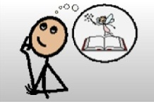

Picture

Say Self

Partner 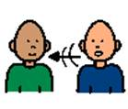



Story hand

Description: j0123493

Touch pages



Sketch



Write

Revise 

Writer’s Writer’s Notebook Notebook



___________ ___________

___________ ___________

___________ ­­ ___________

___________ ___________

___________ ___________

___________ ___________

___________ ___________

___________ ___________

___________ ___________

___________ ­­___________

___________ ___________

___________ ___________

___________ ___________

___________ ___________

___________ ___________

___________ ___________

___________ ­­___________

___________ ___________

___________ ___________

|  |  |
| --- | --- |
| **Ways to Practice My Story**      **Self**    **Partner**  Description: C:\Users\Jen\Desktop\image001.jpg    **Story Hand**  Description: Blank Handprint    **Story Across Pages**  **--Touch pages**  Description: j0123493  Description: j0123493  Description: j0123493  **Sketch**    **Story timeline**  **🡨-.---.---.---.---.---.---.-🡪**  Biondo, May 2011 | **Ways to Practice My Story**    **Self**    **Partner**  Description: C:\Users\Jen\Desktop\image001.jpg    **Story Hand**  Description: Blank Handprint    **Story Across Pages**  **--Touch pages**  Description: j0123493Description: j0123493Description: j0123493  **Sketch**      **Story timeline**  **🡨-.---.---.---.---.---.---.-🡪**  Biondo, May 2011 |

**Class Profile of Teaching and Learning Points – 1st Grade Unit 4: Apprenticeship Writing Studying Craft Optional Assessment/Conferring Tool**

|  |  |  |  |  |  |  |  |  |  |  |  |  |  |  |  |  |  |
| --- | --- | --- | --- | --- | --- | --- | --- | --- | --- | --- | --- | --- | --- | --- | --- | --- | --- |
| Student Names | Writers generate and collect important topics by using authors as mentors. | Writers choose the best topic by exploring their own knowledge and feelings. | Writers develop their topic by using a timeline. | Writers show, not tell using their five senses. | Writers use dialogue tags to enhance meaning. | Writers use temporal words to signal a change in events. | Writers use ellipses to build suspense. | Writers craft a lead to entice the reader to the heart of the story. | Writers can try to end their stories like their favorite authors do. | Writers use their “just-right” books to mentor their own writing. | Writers talk about authors they are using as mentors and the craft moves they are trying. | Writers thoughtfully revisit authors for specific help | Writers use revision/editing checklists | Writers include a title, dedication page, and an About the Author page. |  |  |  |
|  |  |  |  |  |  |  |  |  |  |  |  |  |  |  |  |  |  |
|  |  |  |  |  |  |  |  |  |  |  |  |  |  |  |  |  |  |
|  |  |  |  |  |  |  |  |  |  |  |  |  |  |  |  |  |  |
|  |  |  |  |  |  |  |  |  |  |  |  |  |  |  |  |  |  |
|  |  |  |  |  |  |  |  |  |  |  |  |  |  |  |  |  |  |
|  |  |  |  |  |  |  |  |  |  |  |  |  |  |  |  |  |  |
|  |  |  |  |  |  |  |  |  |  |  |  |  |  |  |  |  |  |
|  |  |  |  |  |  |  |  |  |  |  |  |  |  |  |  |  |  |
|  |  |  |  |  |  |  |  |  |  |  |  |  |  |  |  |  |  |
|  |  |  |  |  |  |  |  |  |  |  |  |  |  |  |  |  |  |
|  |  |  |  |  |  |  |  |  |  |  |  |  |  |  |  |  |  |
|  |  |  |  |  |  |  |  |  |  |  |  |  |  |  |  |  |  |
|  |  |  |  |  |  |  |  |  |  |  |  |  |  |  |  |  |  |
|  |  |  |  |  |  |  |  |  |  |  |  |  |  |  |  |  |  |
|  |  |  |  |  |  |  |  |  |  |  |  |  |  |  |  |  |  |
|  |  |  |  |  |  |  |  |  |  |  |  |  |  |  |  |  |  |
|  |  |  |  |  |  |  |  |  |  |  |  |  |  |  |  |  |  |
|  |  |  |  |  |  |  |  |  |  |  |  |  |  |  |  |  |  |
|  |  |  |  |  |  |  |  |  |  |  |  |  |  |  |  |  |  |
|  |  |  |  |  |  |  |  |  |  |  |  |  |  |  |  |  |  |
|  |  |  |  |  |  |  |  |  |  |  |  |  |  |  |  |  |  |
|  |  |  |  |  |  |  |  |  |  |  |  |  |  |  |  |  |  |
|  |  |  |  |  |  |  |  |  |  |  |  |  |  |  |  |  |  |
|  |  |  |  |  |  |  |  |  |  |  |  |  |  |  |  |  |  |
|  |  |  |  |  |  |  |  |  |  |  |  |  |  |  |  |  |  |

**1st Grade–Apprenticeship Writing: Studying Craft Unit Proficiency Checklist**

**Name: ____________________________________________Date: ____________________________**

Proficiency checklists guide teachers on what to provide instruction and additional assistance on during

the unit, as well as beyond the unit. See Proficiency Guidelines in the K-2 Writing Assessment Package

for additional information. 

|  |  |
| --- | --- |
| **What are this writer’s strengths?** | **What are the next teaching points for this**  **writer?** |

**Approaching Proficiency with Apprenticeship Writing: Studying Craft**

* Does not yet meet requirements for Proficient

**Proficient (Meets Standards) with Apprenticeship Writing: Studying Craft**

**Inquiry-based unit with observable expectations (not always clearly evident in written work). This unit builds**

**on the work of Unit 1.**

**Proficient students must meet all bold and 3 of 4 un-bolded proficient criteria**

* **(T) Evidence of telling story bit-by-bit (Session 2)**
* (T) Evidence of story timeline (Session 3)
* **(T) Notes 2-3 places to add 5 senses (Session 4)**
* **(T) Evidence of some mentor text craft (dialogue tag, temporal words, ellipsis) (Session 5, 6, 7)**
* **(P) Revises for effective lead (physical description or setting) (Session 8, 11)**
* **(P) Revises for effective ending (forward, back, commentary) (Session 9, 11)**
* (P) Demonstrates workshop routines: emphasis on partnership (Session 8, 9, 10, 11)
* (P) Partnership results in improved writing (Session 8, 9, 10, 11)
* (T) Demonstrates knowledge learned from an author (Session 12)

See page 26 of the ELA CCSS document for all 1st Grade Language Standards

**Exceeding Proficiency with Apprenticeship Writing: Studying Craft**

**Students must meet all the Proficient and Exceeding Proficiency criteria**

* (T) Multiple story timelines (Session 3)
* **(T) Notes 4 or more places to add senses (Session 4)**
* **(P) Evidence of trying multiple different leads (Session 8)**
* **(P) Evidence of trying multiple different endings (Session 9)**
* (T) Demonstrates knowledge learned from several authors (Session 12)

**T**-Text Types and Purposes **R**-Research to Build and Present Knowledge **P**-Production and Distribution of Writing **L**

Language

Created by Melissa Wing, Genesee Intermediate School District, Kathy Smith, Bendle Public Schools, Pam Bachner and Aimee Torok, Grand Blanc Schools. (Updated July 2013)

**Each lesson has a share component. Modify based on students’ needs. The following are other share options.**

**Some Possibilities for Purposeful Use of the Share Time**

|  |  |  |
| --- | --- | --- |
| Name | Purpose | Method |
| Follow-Up on Mini-Lesson | To reinforce and/or clarify the teaching point | * Share an exemplar model (student or teacher) * Share a student who had difficulty and the way in which he/she solved the problem * Share the story of a conference from the independent work time * Provide another opportunity for active engagement * Provide a prompt to initiate student conversation, “Turn and tell your partner…” |
| Problem Solving | To build community and solve a problem |  |
| Review | * To recall previous strategies /prior learning * To build repertoire of strategies * To contextualize learning | Pose a “review” question to the class: “Today we learned one revision strategy. What other revision strategies do you use?” These strategies may be listed on a chart. |
| Looking Ahead to Tomorrow | Introduce a new teaching point – set-up for the next mini-lesson |  |
| Celebratory | * Celebration of learning * Boost student morale * Promote membership in the “literacy club” | * Share the work of 2-3 students * Provide an opportunity for a whole class share: “You are all such amazing writers - you wrote so much today! Writers, hold up your open notebooks so that we can see all of the great work you have done.” |

Source: Teachers College Reading and Writing Project



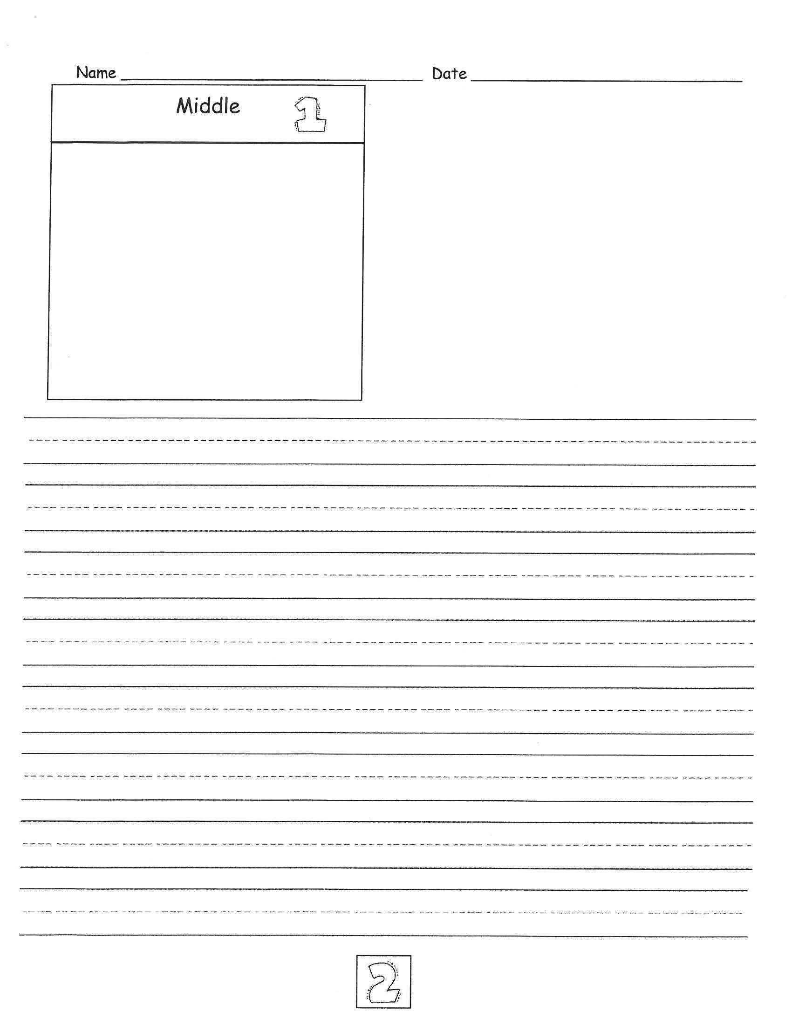

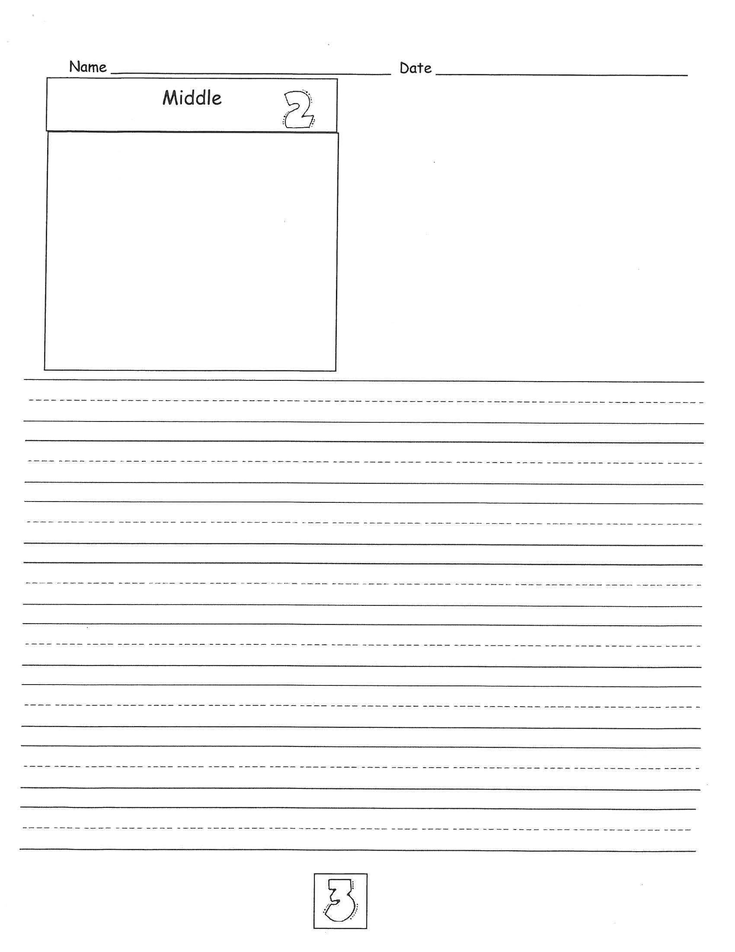

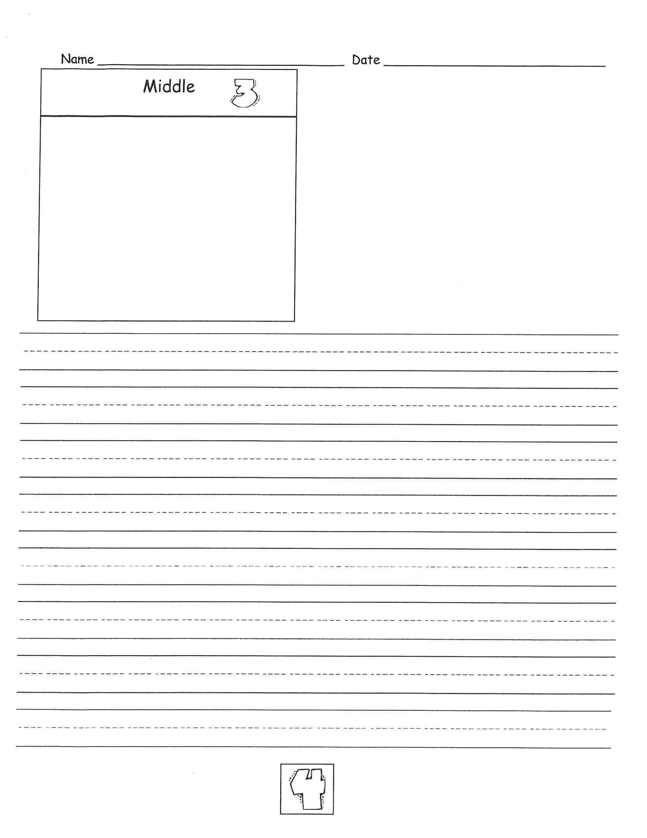

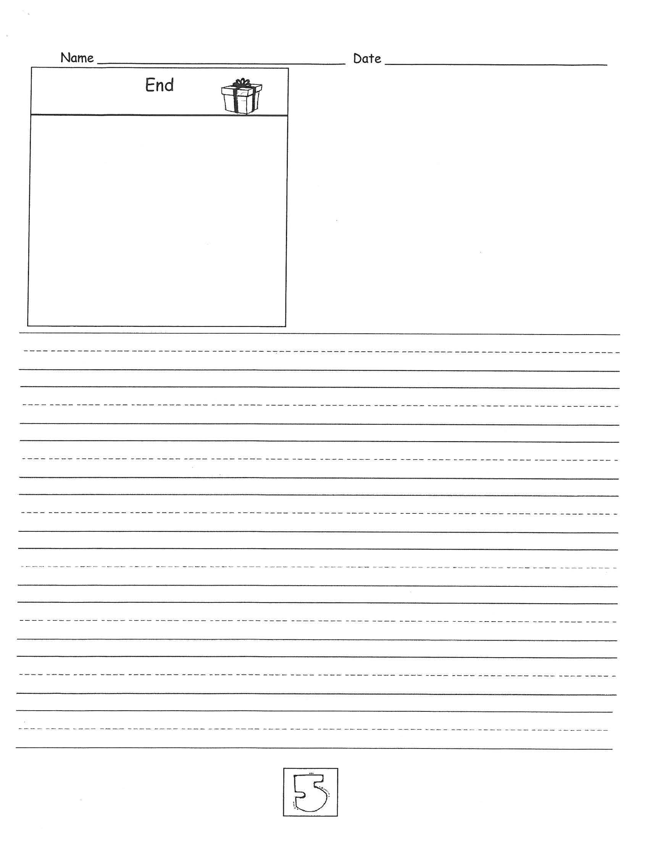

**STUDYING CRAFT CHECKLIST**

**Revision Checklist…**

* I reread my writing. _____
* My writing makes sense. _____
* I have a lead that connects to the heart of the story. _____
* I used at least **ONE** idea from a

mentor author. _____

* I ended my story like one of my favorite authors. _____
* I added details to my writing._____

**Editing Checklist…**

* I have end punctuation .!? _____
* My end punctuation is followed by a capital. _____
* My word wall words are spelled correctly. _____
* I have a capital on all names. _____
* I have spacing._____

My Signature

X______________________________

My Writing Partner’s Signature

X_______________________________

**STUDYING CRAFT CHECKLIST**

**Revision Checklist…**

* I reread my writing. _____
* My writing makes sense. _____
* I have a lead that connects to the heart of the story. _____
* I used at least **ONE** idea from a

mentor author. _____

* I ended my story like one of my favorite authors. _____
* I added details to my writing._____

**Editing Checklist…**

* I have end punctuation .!? _____
* My end punctuation is followed by a capital. _____
* My word wall words are spelled correctly. _____
* I have a capital on all names. _____
* I have spacing._____

My Signature

X______________________________

My Writing Partner’s Signature

X_______________________________