AIMS/web Plus
Benchmark Testing
Installing the TestNav App

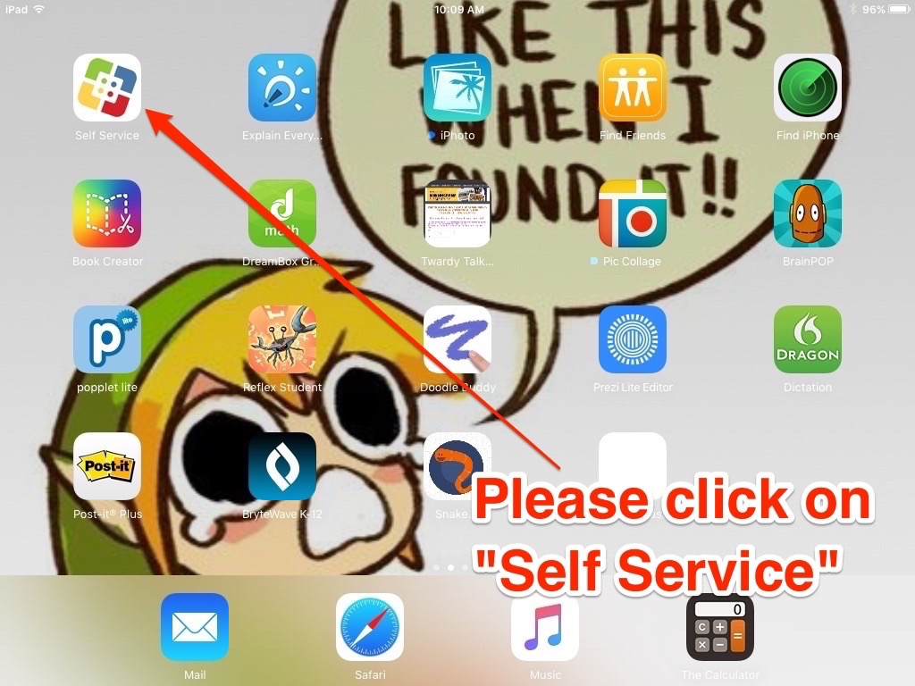

Step One (see figure 1)
- Find the “Self Service app on your iPad.
- Click on it so it opens.

Figure One
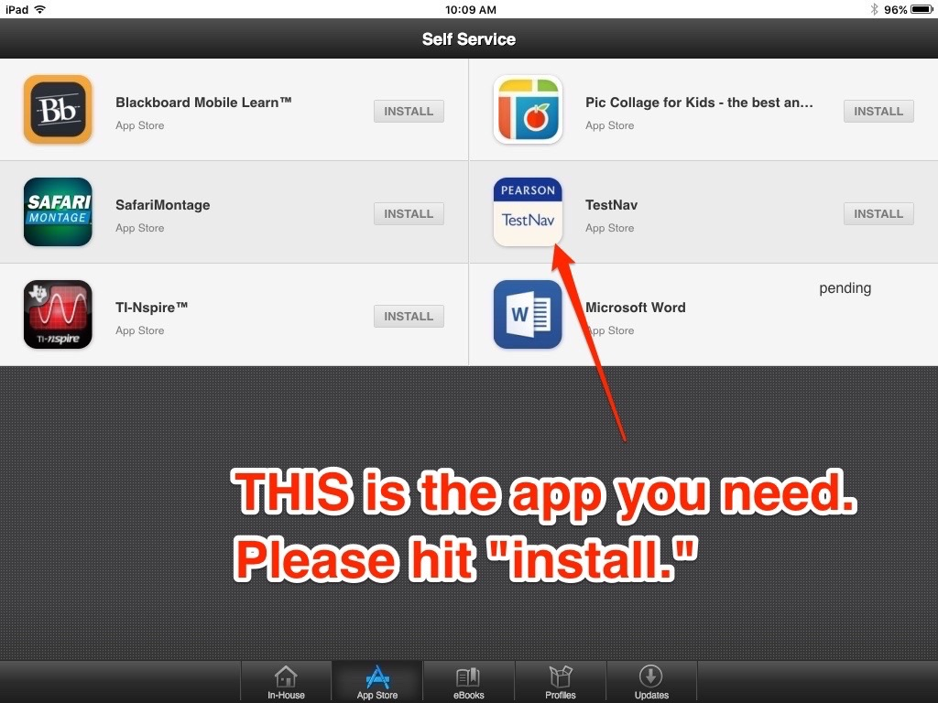

Step Two (see figure 2)
- Find “TestNav” app on the Self Service page
- Click the “install” button on the right of the app.
Figure Two

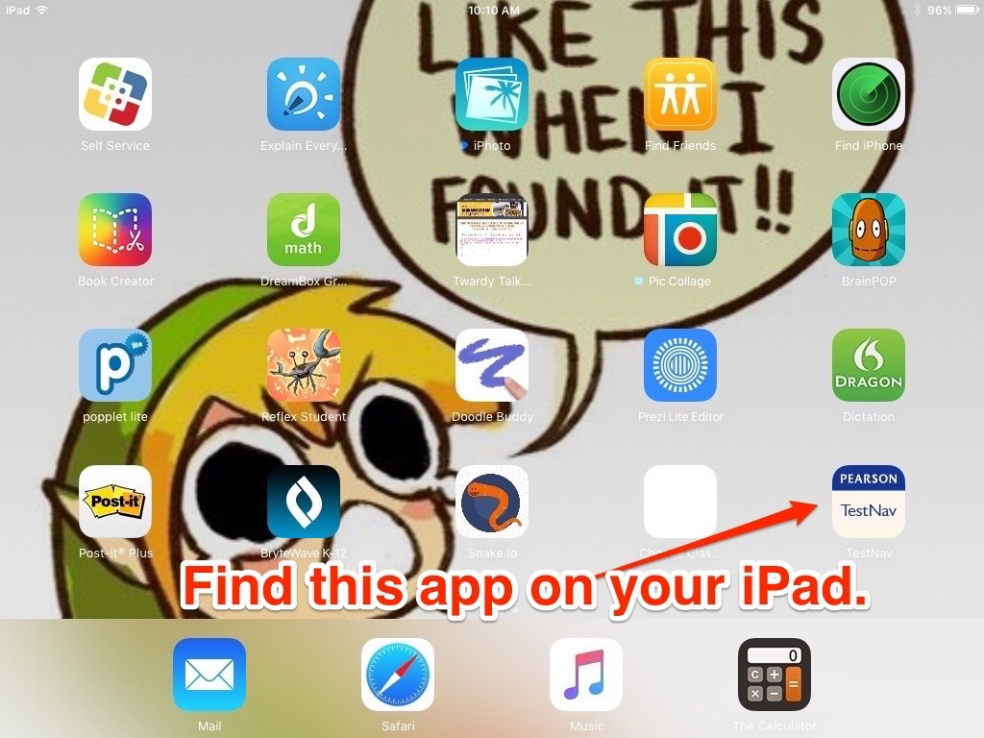
Step Three (see figure 3)
- Scroll through your iPad screens and find the app that says “Pearson TestNav.”
- When you find it, give yourself a high five. You uploaded the app exactly right.

Figure Three

