AIMS/web Plus
Benchmark Testing
Using the TestNav App to Test
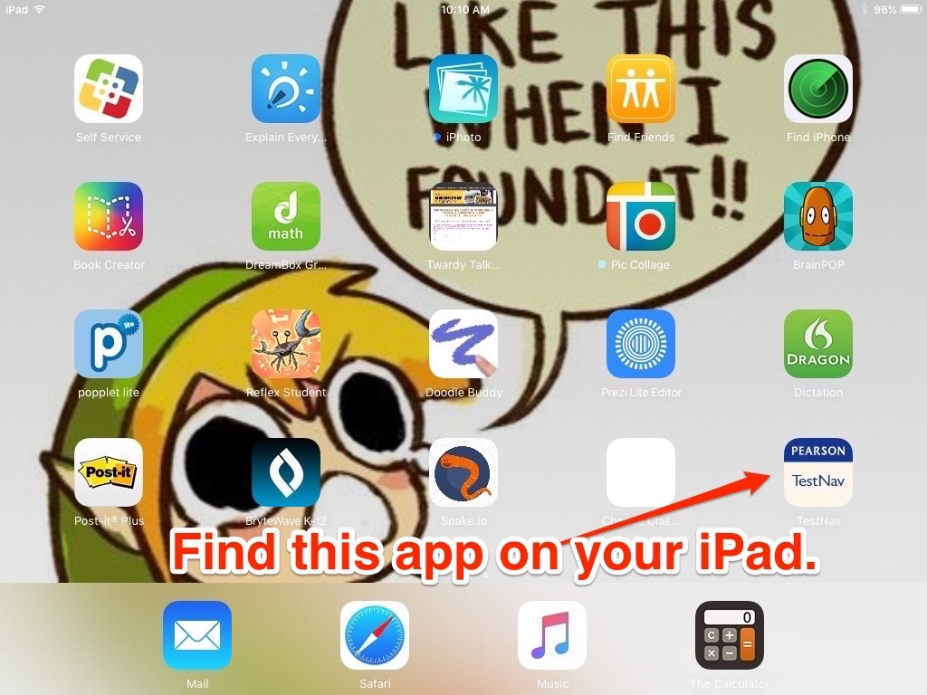

Step One (see figure 1)
- Scroll through your iPad screens and find the app that says “Pearson TestNav.”
- Click it to open it.

Figure One

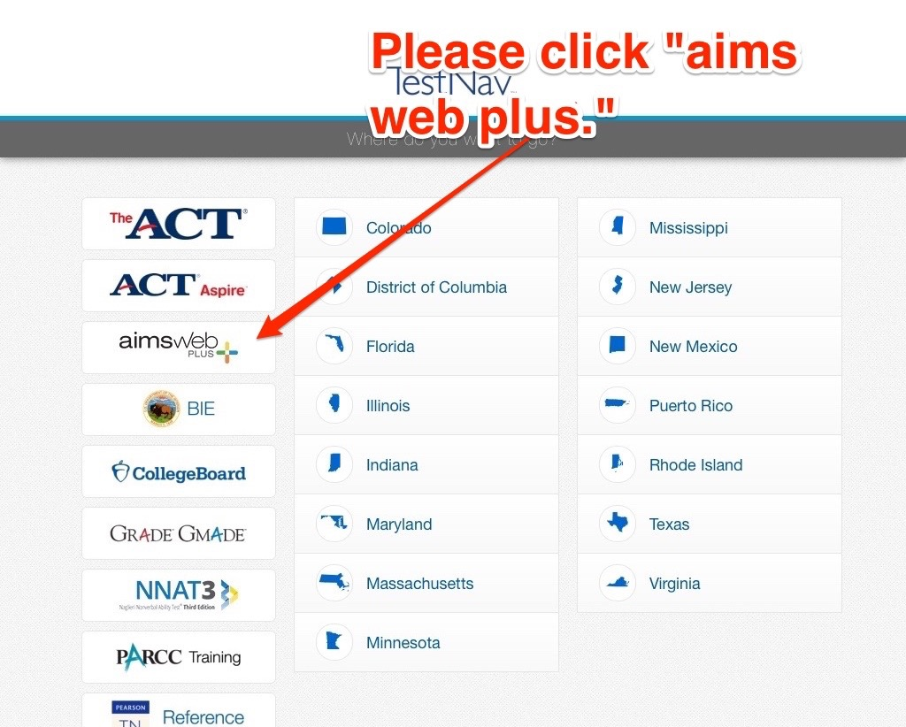
Step Two (see figure 2)
- Find the “aimswebplus” option.
- It is the third one down on the first column.
- Click that.

Figure Two

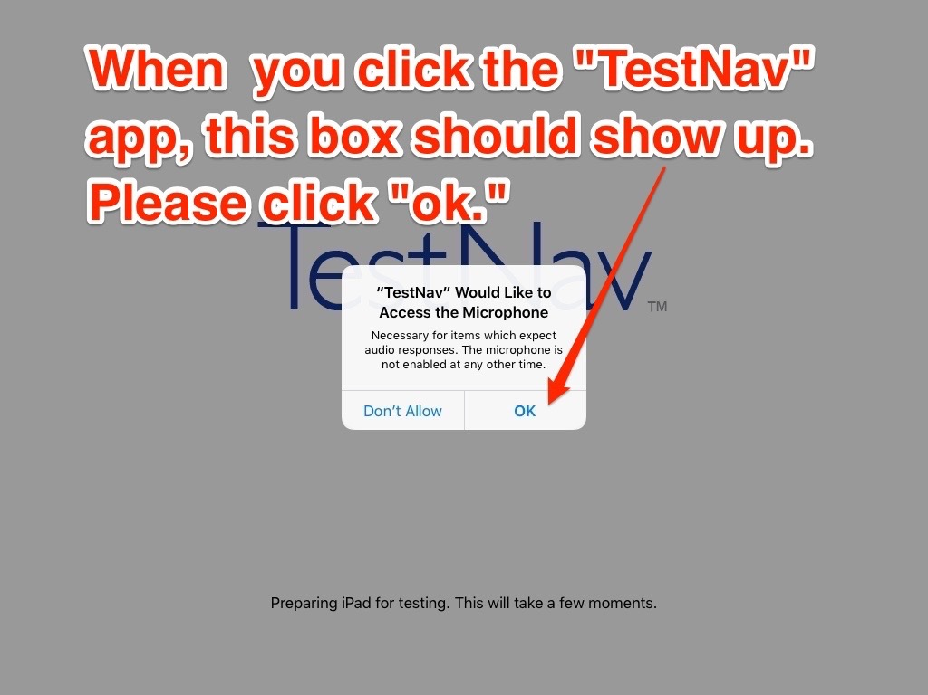
Step Three (see figure 3)
- A white box will pop up on the display screen.
- It will ask about accessing the microphone.
- Click “Ok.”

Figure Three
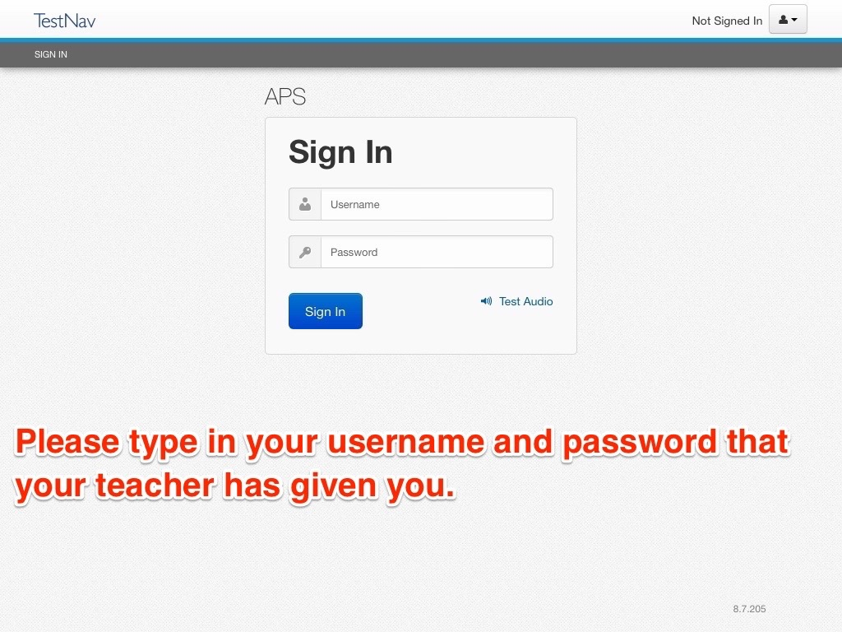
Step Four (see figure 4)
- Use the username, password your teacher gave you and fill in “username” and “password.”
- Click “Sign In.”
Figure Four

