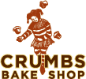
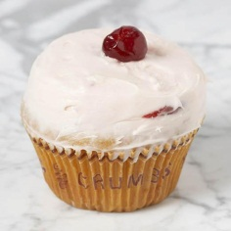

CRUMBS BAKE SHOP
RESTAURANT REVIEW

Ben and Jerry’s is famous for ice cream, Starbucks for coffee, and in my part of New York City, Crumbs is famous for cupcakes. Crumbs is the best bakery for cupcakes.
“When you walk in, you will see three shelves of cupcakes and they’ll come in all the colors of the rainbow. You will smell the sweet, warm smell of newly baked cupcakes,” said a customer that goes there at least twice a week.
The colorful cupcakes in the window suggest this shop is for kids, but one whiff of the fresh-baked air and everyone in your home will want to have a bite of these tasty treats.
Crumbs is the best bakery in my neighborhood because they have a beautiful display of all their cupcakes so you can see what is available.
The people who work at Crumbs are always friendly.
Another reason Crumbs is the best bakery is that the cupcakes are sweet but not too sweet, with the perfect amount of frosting, about a half of an inch!
Crumbs is the best bakery for cupcakes. It gets 5 out of 5 !

Simplified Version Source: Taylor, Sarah Picard. 2008. A quick guide to teaching persuasive writing. Portsmouth, NH: Heinemann.

