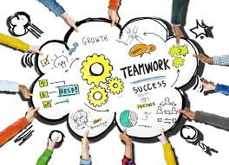 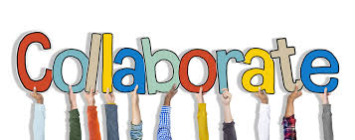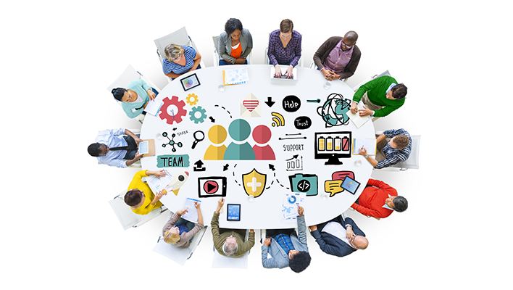

SCIENCE PRACTICES

1. Ask questions

2. Develop and use models

3. Plan and carry out investigations

4. Analyze and interpret data

5. Use Mathematics

6. Construct explanations

7. Engage in argument from evidence

8. Obtain, evaluate, and communicate information.

# **Modifying traditional lessons to meet today’s science standards**

In a traditional science classroom content comes before activity. The teacher provides students with information through lectures or readings and then students complete various tasks to reinforce the information that they have been given. Previous activities were structured in such a way that students simply followed directions in order to verify that the content that they had learned was correct.

Modeling rearranges the instruction so that students complete the activities first. The teacher never provides students with information at all! Instead, students uncover and discover content through carefully orchestrated class discussions and activities. The teacher’s role is simply to facilitate the discussions and help the group come to a consensus that is in line with current scientific ideas. Through this process, students gain a deeper understanding of the subjects that they are taught and they own the knowledge. Along the way, students have multiple opportunities to practice the eight science skills that real scientists use on a daily basis! “Tell me and I’ll forget; Show me and I may remember; Involve me and I learn” - Benjamin Franklin

WHAT ARE MODELS?

Science practice #2 states that students should be able to create and use scientific models. Done correctly, this practice becomes the foundation for each instructional unit. Teachers can choose models that are **physical, verbal, graphical, mathematical, or action based.** Throughout the unit, students revisit and revise models as they uncover new information.

Modeling is an instructional practice that uses collaboration to generate knowledge. Students work together to discover concepts using all eight of the science practices. Modeling uses science practices to uncover knowledge and connect students to other disciplines.

Instructional practices for teaching science skills

Three dimensional instruction

1. ***Anticipating*** how students are likely to respond to a task- Consider not only the **difficulty level** and **engagement**, but **misconceptions** that students might have. Try out new tasks before giving them to students. Use research and previous experience to anticipate misconceptions.

2. ***Monitor*** what students actually do as they work on the task in pairs or small groups- Use **walk around rubrics** to make notes about student engagement and learning. These notes can then be used later to guide the whole class discussion. If you are using the walk-around to assess student learning or skill, don’t over emphasize what you are doing! It will shut them down. They will focus on what you are assessing instead of the process.

3. ***Select*** particular students to present work during whole class discussion- Teachers can select students **randomly** or as part of a more **strategic plan** to flush out misconceptions, good ideas, and those that were not engaged during the activity. If one person seems to dominate a group, select one of the others to present the group’s ideas. “Can someone from April’s group explain your thoughts?”. April won’t answer.☺

4. ***Sequence*** student work or the products that will be displayed in a specific order- Don’t start with the best presentation! Start with the least developed ideas and then add on to them. **Misconceptions first**.

5. ***Connect*** different students’ responses to each other and connect the responses to your learning goals- Groups will get off task! If they can’t agree, bring them back to the evidence or simply say “we need more evidence” and then have them complete another task. **Don’t give the answer.** Use strategic talk moves to bring the conversation back to your original goal.

# **Five Practices for orchestrating productive task-based discussions in science**

MODIFYING CURRENT TASKS

**1. Eliminate or minimize prescriptive directions**- have students develop the protocol as small groups, compare procedures, and then build a class consensus. When safe, allow students the opportunity to try and fail instead of telling them what to do.

**2. Provide complex data**- ask students to transform data in order to identify trends. Graph it, determine the mean, calculate a percent change, etc.

**3. Give students an audience**- provide students with the opportunity to present to peers and to critique and compare the work of others with their own.

**4. Re-sequence tasks**- **A**ctivity **B**efore **C**ontent. Use activities to uncover content instead of just providing empirical evidence for knowledge that students have already been given.

**5. Change it up**- Doing the same type of task over and over tends to decrease the learning power. Change things up! Have students play games, read research, watch videos, graph, build things, etc.

Next Generation Science Standards

Traditional classrooms focused on content. Skills were reserved for lab days, and cross cutting concepts were rarely considered. The Next Generation Science Standards introduced us to three-dimensional instruction in which all three dimensions are practiced and assessed together.

RATE YOUR LESSON PLAN. RATE YOURSELF!

If you focus on one dimension, you are a 33% instructor. Your grade is an F.

If you incorporate two dimensions, you are working at 67%. Your grade is a D+.

If you incorporate three dimensions, you are a great teacher. Your grade is an A.

Food for thought:

LS ES PS grades K, 1, 2

LS ES PS grades 3, 4, 5

LS ES PS grades 6, 7, 8

LS ES PS grades 9, 10, 11

Students experience each content area four times in twelve years. By contrast, they practice the skills in all twelve grades. The cross cutting concepts are also incorporated into all science classes. Some might argue that the cross cutting concepts span various disciplines making them the most practiced and assessed of the three dimensions.

Content = 4 years

Practices = 12 years

Cross Cutting Concepts = up to 60 years

The emphasis is already on Cross Cutting Concepts!

SCIENCE PRACTICES

DISCIPLINARY CORE IDEAS

CROSS CUTTING CONCEPTS

Simply trading a content rich curriculum for a skills based curriculum does not do enough to address the three dimensional goals of The Next Generation Science Standards. It just trades one dimension for another. Students must be engaged in all three disciplines on a daily basis.

Instructional practices for teaching science skills

Three dimensional

planning

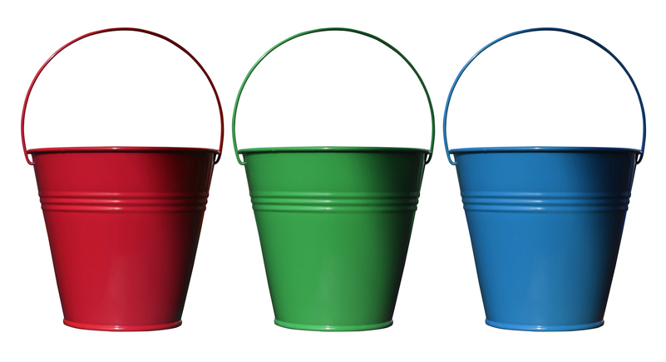 

KEEP ALL THREE DISCIPLINES ON YOUR DESKTOP!

ABC- ACTIVITY BEFORE CONTENT!

DON’T COVER CONTENT- UNCOVER IT!

RATE YOUR ACTIVITIES DAILY!

Which dimension is the most important? How does this athletic model relate to science curriculum? Are skills all that matter? Three-dimensional science is very similar to athletics. The disciplinary core ideas are WHAT we teach (content). The science and engineering practices are HOW we teach (skills). The seven cross cutting concepts are WHY we teach science. Which dimension is the most important for education?

SUMMATIVE ASSESSMENTS

Three dimensional item writing is easy! Just separate the content, skills, and cross cutting concepts into three separate buckets. Select one item from each bucket and write! If three-dimensional questions are too difficult, try writing two-bucket questions. Limit the number of single bucket questions that you write. Wait until you have emptied the bucket before replacing an item. That way you are sure to address all areas evenly. Goal: 20% one bucket questions; 20% three bucket questions; 60% two bucket questions. Ie. An assessment with twenty five questions should contain no more than five single bucket questions, at least five three bucket questions, and fifteen questions that incorporate two of the dimensions.

|  |  |  |
| --- | --- | --- |
| Content-  WHAT we play | Skills-  HOW we play | Cross Cutting Concepts-  WHY we play |
| Game rules  Equipment  Strategy | Endurance  Flexibility  Balance  Coordination  Strength  Speed  Agility | Teamwork  Competition  Fitness  Fun  Passion |

Three Dimensional Athletics

Instructional practices for teaching science skills

FORMATIVE ASSESSMENTS

Content- Use vocabulary quizzes, problem sets, and free response questions.

Skills- Use CER (claim, evidence, reasoning) statements, exit tickets, and walk around rubrics.

CCC- Use performance tasks

CROSS CUTTING CONCEPTS

1. Patterns

2. Cause and Effect

3. Scale, Proportion, and Quantity

4. Systems

5. Energy and Matter

6. Structure and Function

7. Stability and Change

CONTENT

SKILLS

CCC

The process of science leads to knowledge and engineering practices lead to solutions. It is for knowledge and solutions that we practice science and engineering skills. Activities without content are just activities.

Three dimensional

assessments

* collaborate to investigate and strengthen scientific understanding and skills.
* recognize that science is integrated in and out of the classroom.
* persevere through the challenges of science and accept the difficulties in the science process.
* demonstrate my curiosity of the natural world by asking questions and seeking answers.
* collect, organize, evaluate, and analyze data.
* approach new and complex problems using critical thinking skills.
* draw reasonable conclusions from evidence.
* design and conduct an investigation.
* communicate and understand science through reading, writing, and verbal discourse.

I CAN….