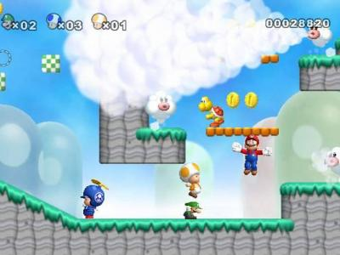
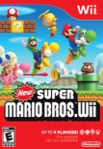

New Super Mario Bros. Wii

A Video Game Review

I play a TON of video games, so when I say New Super Mario rocks, you know it is true!!! New Super Mario Brothers for the Wii is based on a popular video game from a long time ago that Nintendo has brought back, only now it is better than before. You get to fight, jump and climb through the Mushroom kingdom to save the princess. It is rated “E” for everyone so even your little sister can play. It costs about $50.00 and you can buy it at Target, K-mart or Meijer. New Super Mario Bros. Wii is easy to pick up and hard to put down. This game is totally fabulous!

With Super Mario Bros you will never be bored because it features more than 80 colorful levels! Worlds range from lush green towns to cloud-filled skies, dry deserts to icy levels, dark dungeons, and so on. My dad even said, “I remember Mario from when I was a kid, I loved the water level.”
There are lots of ways to play. You can play alone or you can play with up to four friends at the same time. There are even some functions that require to people to cooperate to be successful like the seesaw. You are not just competing against each other sometimes you are working together.

This game includes many well-hidden secrets and surprises as a reward to those who explore. It could be extra coins and power-ups, underground caverns or . . . the ability the warp to future worlds.
Super Mario Bros is pretty easy to play. Gamers simply hold the Wii Remote sideways to control their character, pressing the 1 and 2 buttons to jump or shoot, and shaking the controller to float around.
Wii is an extraordinary game. I give it 5 stars. I can’t think of anything about it I don’t love! Put this game on the top of your birthday list, you won’t be sorry!!!

Adapted from an original review at www.commonsensemedia.org/game-reviews/new-super-mario-bros-wii

